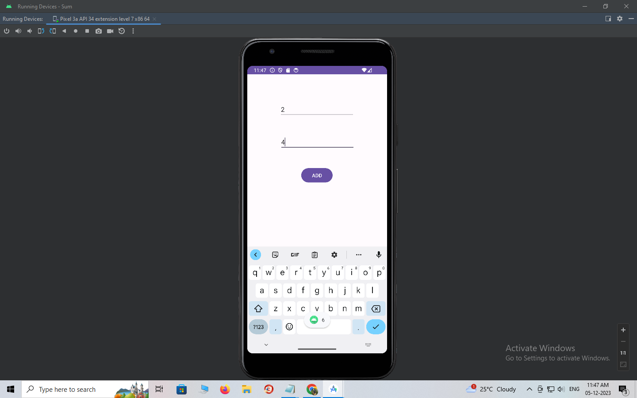

To check the memory usage, click on the **profiler and click on + and add present emulator**

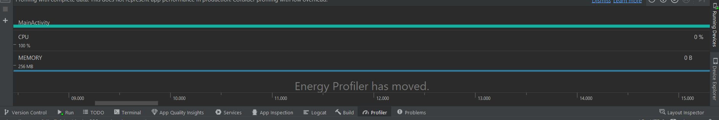

Select your emulator and check the memory allocation

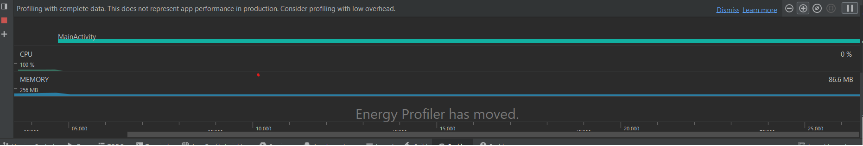

Now stop the activity and see the changes

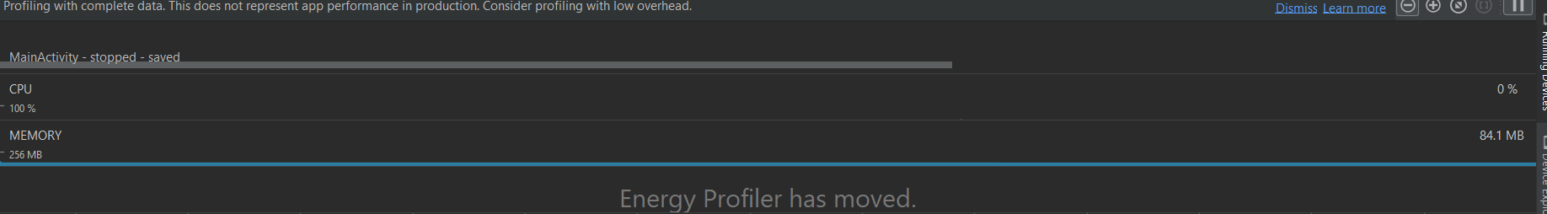

Finally delete the activity

